**CHAPTER FOUR**

**Internet Consumer Retailing**

**4.1 Introduction and Definition of Terms**

A retailer is a sales intermediary, a seller that operates between manufacturers and customers. Even though many manufacturers sell directly to consumers, they supplement their sales through wholesalers and retailers (a multichannel approach). In the physical world, retailing is done in stores (or factory outlets) that customers must visit in order to make a purchase. Companies that produce a large number of products, such as Procter 8c Gamble, must use retailers for efficient distribution. Catalog sales offer companies and customers a relief from the constraints of space and time: Catalogs free a retailer from the need for a physical store from which to distribute products, and customers can browse catalogs on their own time. With the ubiquity of the Internet, the next logical step was for retailing to move online. Retailing conducted over the Internet is called electronic retailing, or e-tailing, and those who conduct retail business online are called e-tailers. E-tailing also can be conducted through auctions. E-tailing makes it easier for a manufacturer to sell directly to the customer, cutting out the intermediary (e.g., Dell and Godiva).

**Products known to sell on the internet.**

With approximately 118 million shoppers online in the United States in 2005, e-tailers appreciate the need to provide excellent choice and service to an ever-increasing cohort of potential customers. Hundreds of thousands of items are available on the Web from

numerous vendors. The following categories are all selling well online; Travel (tickets and reservations), Consumer hardware and software , consumer electronics, office supplies, sports and fitness goods, books and music, toys, health and beauty products, entertainment, clothing, jewelry, cars, services, pet supplies among others.

**Characteristics of Successful E-Tailing**

Many of the same basic principles that apply t0 retail success also apply to e—tail success. Sound business thinking , visionary leadership , thorough competitive analysis and financial analysis, and the articulation of a well—thought—out EC strategy are essential. So, too, is ensuring appropriate infrastructure, particularly a stable and scalable technology infrastructure to support the online and physical aspects of EC business operations. With all else being equal in the online environment, goods with the following characteristics are expected to facilitate higher sales volumes:

 High brand recognition (eg., Lands End, Dell, Sony)

 A guarantee provided by highly reliable or well known vendors (eg., Dell, LL.

Bean)

 Digitized format (eg., software, music, or videos)

 Relatively inexpensive items (e.g., office supplies, vitamins)

 Frequently purchased items (e. g., groceries, prescription drugs)

 Commodities with standard specifications e.g. books CDs airline tickets

 Well-known packaged items that cannot be opened even in a traditional store

(e.g., foods, chocolates, vitamins)

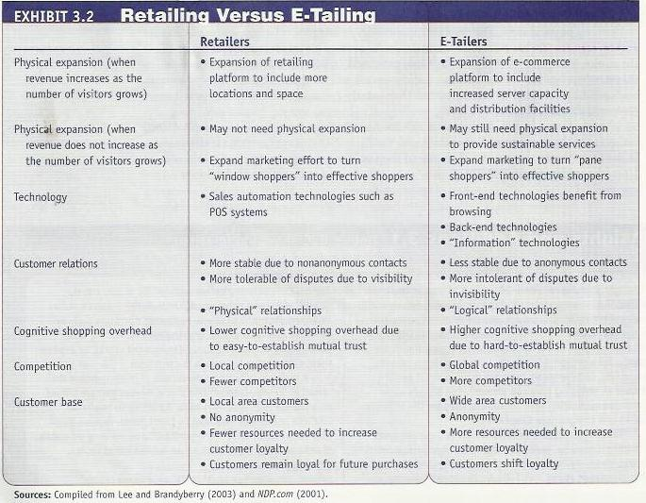

**4.2 E-Tailing Business Models**

In order to better understand e—tailing, let’s look at it from the point of view of a retailer or a manufacturer that sells to individual consumers. The seller has its own organization and must also buy goods and services from others usually businesses B2B.

**Classification by Distribution Channel**

A business model is a description of how an organization intends to generate revenue ` through its business operations. More specifically it is an analysis of the organizations customers and, from that, a discussion of how that organization will achieve profitability and sustainability by delivering goods and services (value) to those customers. E— tailing business models can be classified in several ways for example, some classify e- tailers by the scope of items handled (general purpose versus specialty e-tailing) or by the scope of the sales region covered (global versus regional), whereas others use

classification by revenue models (see Chapter 1). Here we will classify the models by the distribution channel used, distinguishing five categories:

1. Mail-order retailers that go online. Most traditional mail-order retailers, such as QVC, Sharper Image, and Lands’ End, simply added another distribution channel- the Internet. Several of these retailers also operate physical stores, but their main distribution channel is direct marketing.

2. Direct marketing from manufacturers. Manufacturers, such as Dell, Nike, Lego, and Sony, market directly online from company sites to individual customers. Most of these manufacturers are click-and—mortar, also selling in their own physical stores or via retailers. However, the manufacturer may be a pure—play company (e.g., Dell).

3. Pure—play e-tailers. These e—tailers do not have physical stores, only an online

sales presence. Amazon.com is an example of a pure—play e-tailer.

4. Click-and-mortar retailers. These are of two sorts, depending on how the businesses were originally founded. Originally, click-and-mortar referred to traditional businesses that developed Web sites to support their business activities in some way (e.g., walmart.com, homedepot.com, and sharperimage.com). However, we are now seeing the reverse trend. A small number of successful e-tailers are now creating physical storefronts, leveraging the brand power of the online environment to support more traditional trading activities via stores. For example, Expedia.com.

5. Internet (online) malls. these malls include large numbers of independent storefronts.

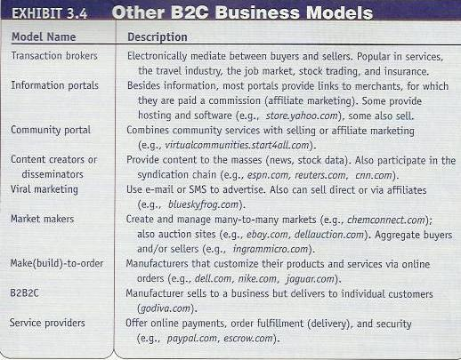

**4.3 Travel and Tourism Services On-line**

Online travel bookings and associated travel services are one of the most successful e- commerce implementations, with estimates of sales of $73.4 billion in 2006. However this was expected to increase by 34% by 2010. The number of travelers using the Internet to plan and book trips is still growing significantly, with some 79 million Americans using the Internet to research travel options and destination information in

2005. Of interest is that now 82 percent of those who do this research online also

convert to booking their travel online. They most often purchase airline tickets, accommodation, and car rentals online, but future growth is expected in associated events such as cultural event tickets, theme/ amusement park tickets, and tickets for sporting events (Tia.org 2005). The most popular types of Web sites are online travel agencies (such as Expedia, Travelocity, and Priceline).

The revenue models of online travel services include direct revenues (commissions), revenue from advertising, lead-generation payments, consultancy fees, subscription or membership fees, revenue-sharing fees, and more. With such rapid growth and success, the travel industry seems to have matured beyond initial concerns such as trust, loyalty, and brand image.

**Services Provided**

Virtual travel agencies offer almost all of the services delivered by conventional travel agencies, from providing general information to reserving and purchasing tickets, accommodations, and entertainment. Tn addition, they often provide services that most conventional travel agencies do not offer, such as travel tips provided by people who have experienced certain situations (e.g., a visa problem), electronic travel magazines, fare comparisons, city guides, currency conversion calculators, fare tracking (free e-mail alerts on low fares to and from a city and favorite destinations), worldwide business and place locators, an outlet for travel accessories and books, experts’ opinions, major international and travel news, detailed driving maps and directions within the United States and several other countries (see infohub.com), chat rooms and bulletin boards, and frequent-flier deals. In addition, some offer several other innovative services, such as online travel auctions.

Some benefits are; The amount of free information is tremendous, and it is accessible at any time from any place. Substantial discounts can be found, especially for those who have time and patience to search for them. Providers of a travel services also benefit: Airlines, hotels, and cruise lines are selling otherwise-empty spaces. Also, direct selling saves the provider’s commission and its processing.

**4.4 The Internet Job Market**

The Internet offers a rich environment for job seekers and for companies searching for hard to find employees. Nearly all Fortune 500 companies now use the Internet for some of their, recruitment requirements, and studies reveal that online resources are now the most popular way to find suitably qualified applicants for job vacancies (Careerbuilder.com 2006). Online, job recruitment revenues and volume overtook print ad classifieds at the end of 2005, and in 2006 were estimated to reach $2.3 billion.

The following parties use the Internet job market:

 **Job seekers**. Job seekers can reply to employment advertisements Or, they can take the initiative and place their CV’s on their own homepages or on others’ Web sites, send messages to members of newsgroups asking for referrals, and use the sites of recruiting firms, such as careerbuilder.com,

 **Employers seeking employees.** Many organizations, including public institutions, advertise openings on their Web sites. Others advertise job openings on popular public portals, online newspapers, bulletin boards, and with recruiting firms. Employers can conduct interviews and administer interactive intelligence, skills, and psychological tests on the Web. Some employers, such as Home Depot, have kiosks in some of their stores on which they post job openings and allow applicants to complete an application electronically

 **Job agencies.** Hundreds of job agencies are active on the Web. They use their own Web pages to post available job descriptions and advertise their services in e-mails and at other Web sites. job agencies and/ or employers use newsgroups, online forums, bulletin boards, Internet commercial resume services, and portals such as Yahoo! Hotlobs and myjobseye.com. Most portals are free; others charge membership fees but offer many services.

 **Government agencies and institutions.** Many government agencies advertise openings for government positions on their Web sites and on other sites; some are required by law to do so. In addition, some government agencies use the Internet to help job seekers find jobs elsewhere, as is done in Hong Kong and the Philippines.

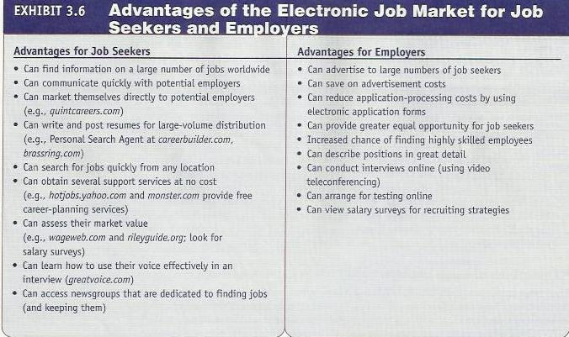

**4.5 Real Estate, Insurance, and Stock Trading On Line**

Online financial services are exploding on the Internet and are being embraced by customers. According to Dandapani (2004), online financial services essentially altered the industry landscape.

**Real Estate On Line**

The increasing presence and realization of e—commerce possibilities and opportunities in the real estate business is creating a momentum and a readiness for change and slowly adding pressure to transform the old ways of doing things in this previously stable and conservative business. Changes are reaching a tipping point, beyond which the nature of the real estate business will be altered. The changes have been some time in coming, but after a long period of quantitative changes experts are beginning to see some fundamental qualitative changes in the industry. Despite the fact that the Internet is shaking up the real estate industry, the emerging pattern is more complex than the simple disintermediation of agents.

Examples of real estate applications are; Advice to consumers on buying or selling a home, Commercial real estate listings, Listings of residential real estate, Information on current mortgage rates, lenders who want to issue mortgages etc.

**On-line Insurance**

The uptake of EC in the insurance industry is comparatively slow in several countries. An increasing number of companies use the Internet to offer standard insurance policies, such as auto, home, life, or health, at a substantial discount. Furthermore, third-party aggregators offer free comparisons of available policies. Several large insurance and risk-management companies offer comprehensive insurance contracts online.

**On-line stock trading**

In the late 1990s, online trading was an exciting innovation in the financial services industry. However, the dot-com crash and increasing competition saw consolidation, cost-cutting, and price reduction become the order of the day. Today the majority of stock trading is carried out via the Internet, with 12 brokerage firms handling 75 percent of online trades (Cropper 2004). The top three brokerage firms after the 2005 mergers are Ameritrade, Charles Schwab, and E-Trade (Regan 2005a).

The commission for an online trade is considerably low. With online trading, there are no busy telephone lines, and the chance for error is small because there is no oral communication in a frequently noisy environment. Orders can be placed from anywhere, at any time, day or night, and there is no biased broker to push a sale. Furthermore, investors can find a considerable amount of free information about specific companies or mutual funds.